GCS Unit Plan Template

Unit Author
Teacher(s) Name
School Name
Unit Overview
Unit Title
Unit Summary
Subject Area
Grade Level
Approximate Time Needed
Unit Foundation
Targeted Content Standards and Benchmarks
Student Objectives/Learning Outcomes
Cross-Curricular Connections
Curriculum-Framing Questions
 |  | Essential Question
 |  | Unit Questions
 |  | Content Questions
Assessment Plan
Assessment Timeline
Before project work begins |  | Students work on projects and complete tasks |  | After project work is completed
- 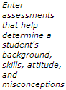 |  | - 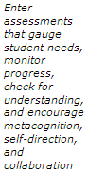 |  | - 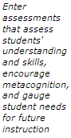

Assessment Summary
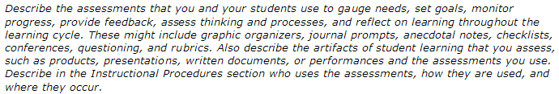
Unit Details
Prerequisite Skills
Instructional Procedures
Accommodations for Differentiated Instruction
 | Special Needs Students |  | 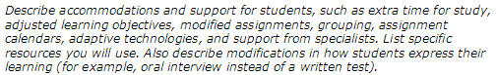
 | Nonnative Speakers |  | 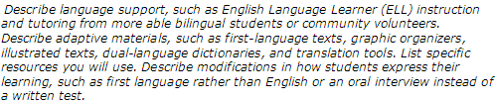
 | Gifted/Talented Students |  | 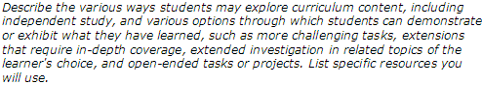
Materials and Resources Required For Unit

Technology – Hardware (Click boxes of all equipment needed)

Interactive Technology  Computer(s)/iPads, etc.  Digital Camera  DVD Player  Internet | Student Response System/Clickers  Printer  Projection System  Scanner  Television | Cell Phone  Video Camera  Video Conferencing Equip.  Document Camera  Other
Technology – Software (Click boxes of all software needed.)
Database/Spreadsheet  Desktop Publishing  E-mail  Web-Based Encyclopedia | Image Processing  Internet Web Browser  Multimedia | Web Page Development  Word Processing  Other

Printed Materials
Supplies

Additional Unit Plan Information

Internet and Additional Resources
List additional resources for the lesson/unit plan or related lesson plans that map to the Common Core Standards in the lesson/unit plan.
Common Core Standard | Resource

Unit Plan Reflection

Describe any adaptations or “tweaks” to the resource or lesson plan that were needed:

What do you plan to do differently the next time you teach this unit?:

